GCNU1003 Speaking of Statistics (1004) - Assignment 6 solution
Chapter 7
1. In the movie Forrest Gump, IQ test scores are normally distributed with mean 100 and standard deviation 16,
  - The public school required an IQ of at least 80 for admittance, what percentage of people would qualify for admittance to the school.
  - If the public school wishes 95 percent of all children to qualify for admittance, what minimum IQ test score should be required for admittance?
  - If four students are randomly selected, what’s the probability of sample mean greater than 80?

Solution:
Let x be the random variable of IQ test score.
- People having an IQ of at least 80 would qualify for admittance to the school.
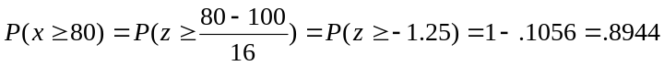
b. Let k be the minimum IQ test score required for admittance if the public school wishes 95 percent of all children to qualify for admittance. Here, we want 95 percent of all children to have scores greater than or equal to k. Hence, we must choose k such that
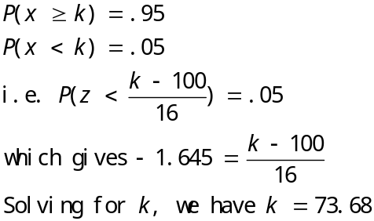

c. 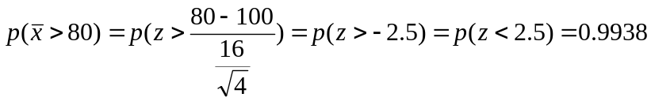
2. Suppose that we will randomly select a sample of 64 measurements from a population having a mean equal to 20 and a standard deviation equal to 4.
- Describe the shape of the sampling distribution of the sample mean. Do we need to make any assumption about the shape of population? Why or why not?
- Find the mean and the standard deviation of the sampling distribution of the sample mean.
- Calculate the probability that we will obtain a sample mean greater than 21.
- Calculate the probability that we will obtain a sample mean less than 19.385.

Solution:
a. The sampling distribution of the sample mean is approximately bell shaped. No need to make any assumption, because the sample size is large (n≥ 30).
b. According to central limit theorem, the sampling distribution of the sample mean is
normally distributed with mean equal to and standard deviation equal
to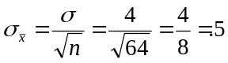
c. The probability that we will obtain a sample mean greater than 21 is: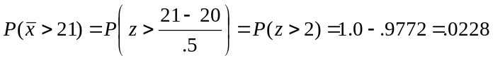
d. The probability that we will obtain a sample mean less than 19.385 is: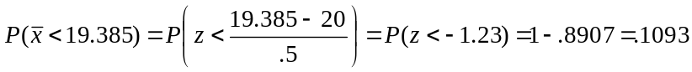

3. The amount of time a bank teller spends with each customer has a population mean minutes and standard deviation minute. If a random sample of 16 customers is selected.
- What is the probability that the average time spent per customer will be at least 3 minutes?
- There is an 85% chance that the sample mean will be below how many minutes?
- What assumption must be made in order to solve (a) and (b)?

Solution: (a) 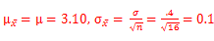
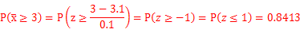
(b)
(c) The population should be normally distributed
4. In the upcoming governor's election, the most recent poll based on 900 respondents predicts that the incumbent will be reelected with 55% of the votes. For the sake of argument, assume that 51% of the actual voters in the state support the incumbent governor (p = 0.51). Calculate the probability of observing a sample proportion of voters 0.55 or higher supporting the incumbent governor.
Solution:
If p=0.48, the sampling distribution of is approximate a normal distribution because np and n(1-p) are both much larger than 5. Furthermore, the mean and standard deviation of the sampling distribution of are
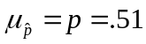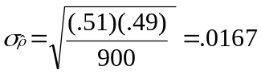
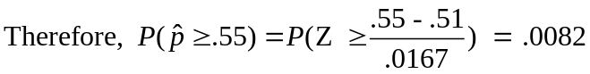

5. Historically, 10% of a large shipment of machine parts is defective. If random samples of 400 parts are selected, what proportion of the samples will has
- Between 9% and 10% defective parts?
- Less than 8% defective parts?

Solution: The sampling distribution of is approximately a normal distribution since np and n(1-p) are both much larger than 5 when p=0.1. Furthermore, the mean and standard deviation of the sampling distribution of are
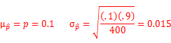
Therefore (a)
